In this tutorial, you’ll learn how to edit an existing sale.
To begin, login to your account by clicking on the ‘Login’ option located at the top of the page.
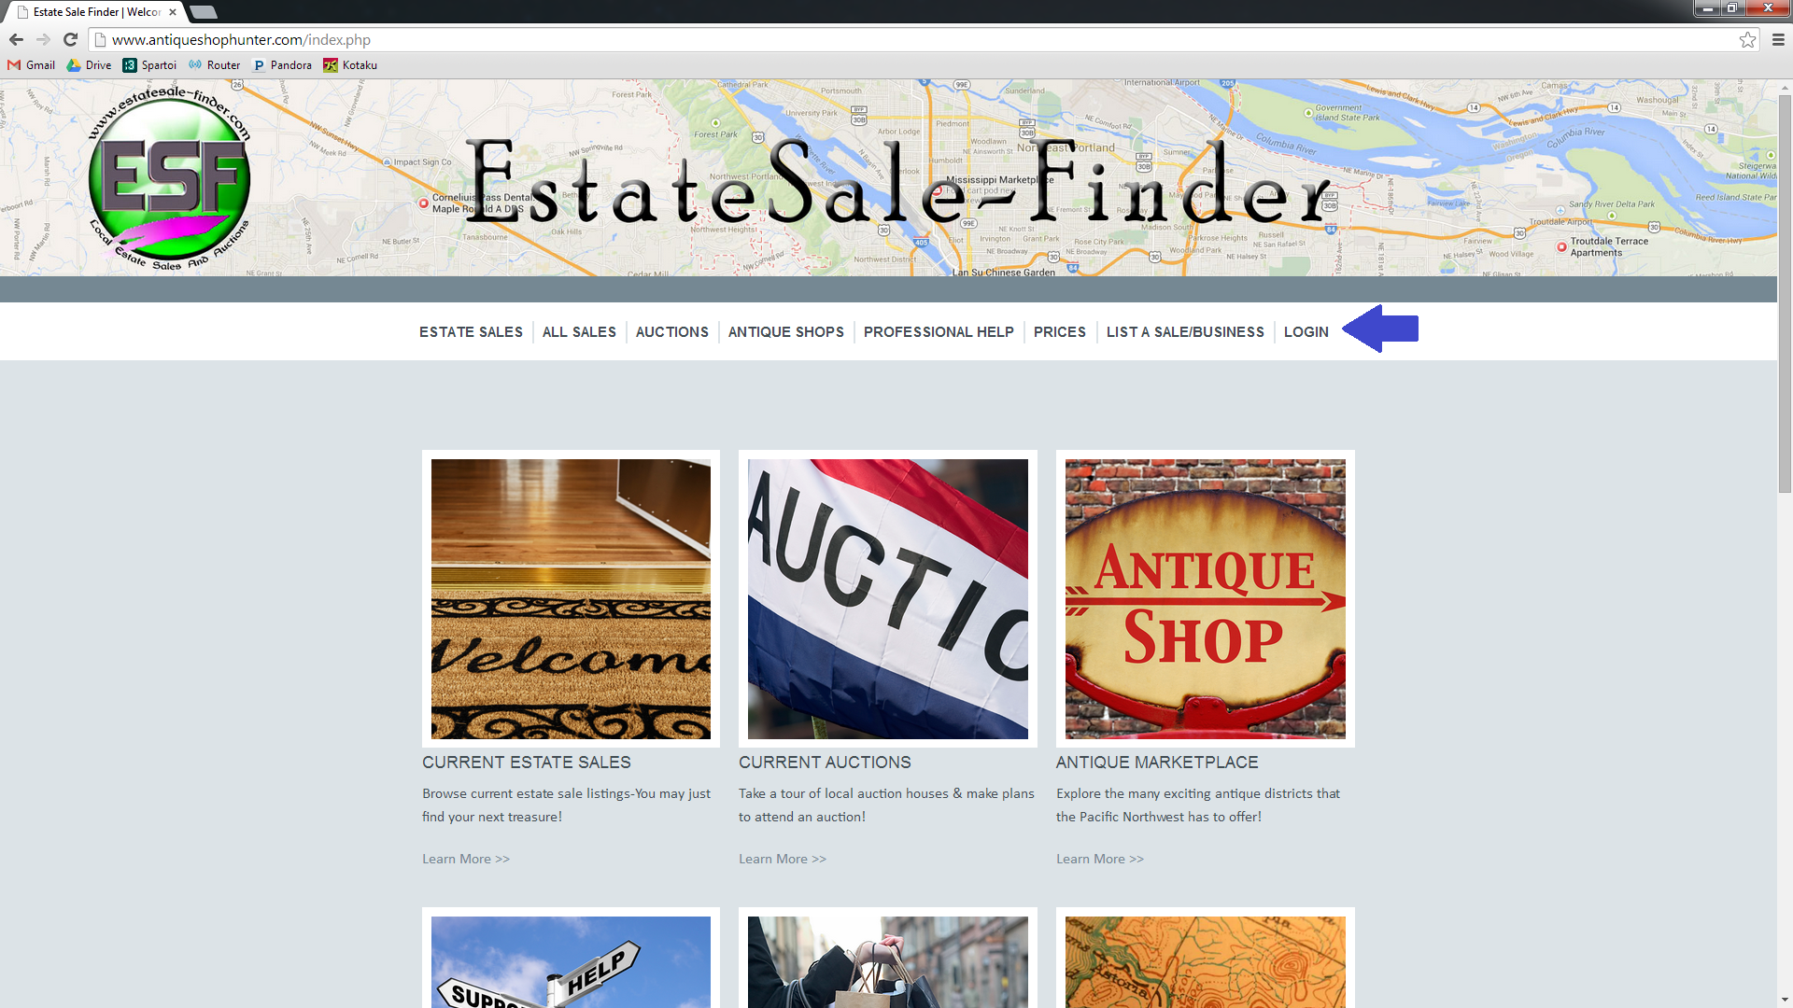

Enter your username and password, and click the ‘Login’ button.
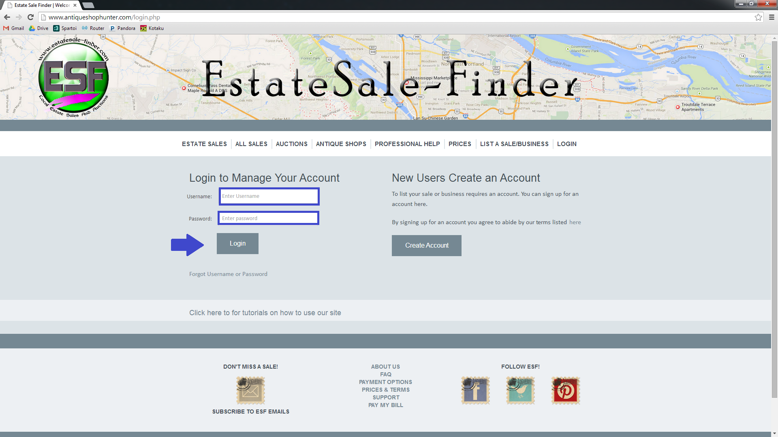

You are now on your account homepage, where your current and upcoming sales are visable. Locate the sale that you wish to edit, and click the ‘Edit’ option in the far right column.
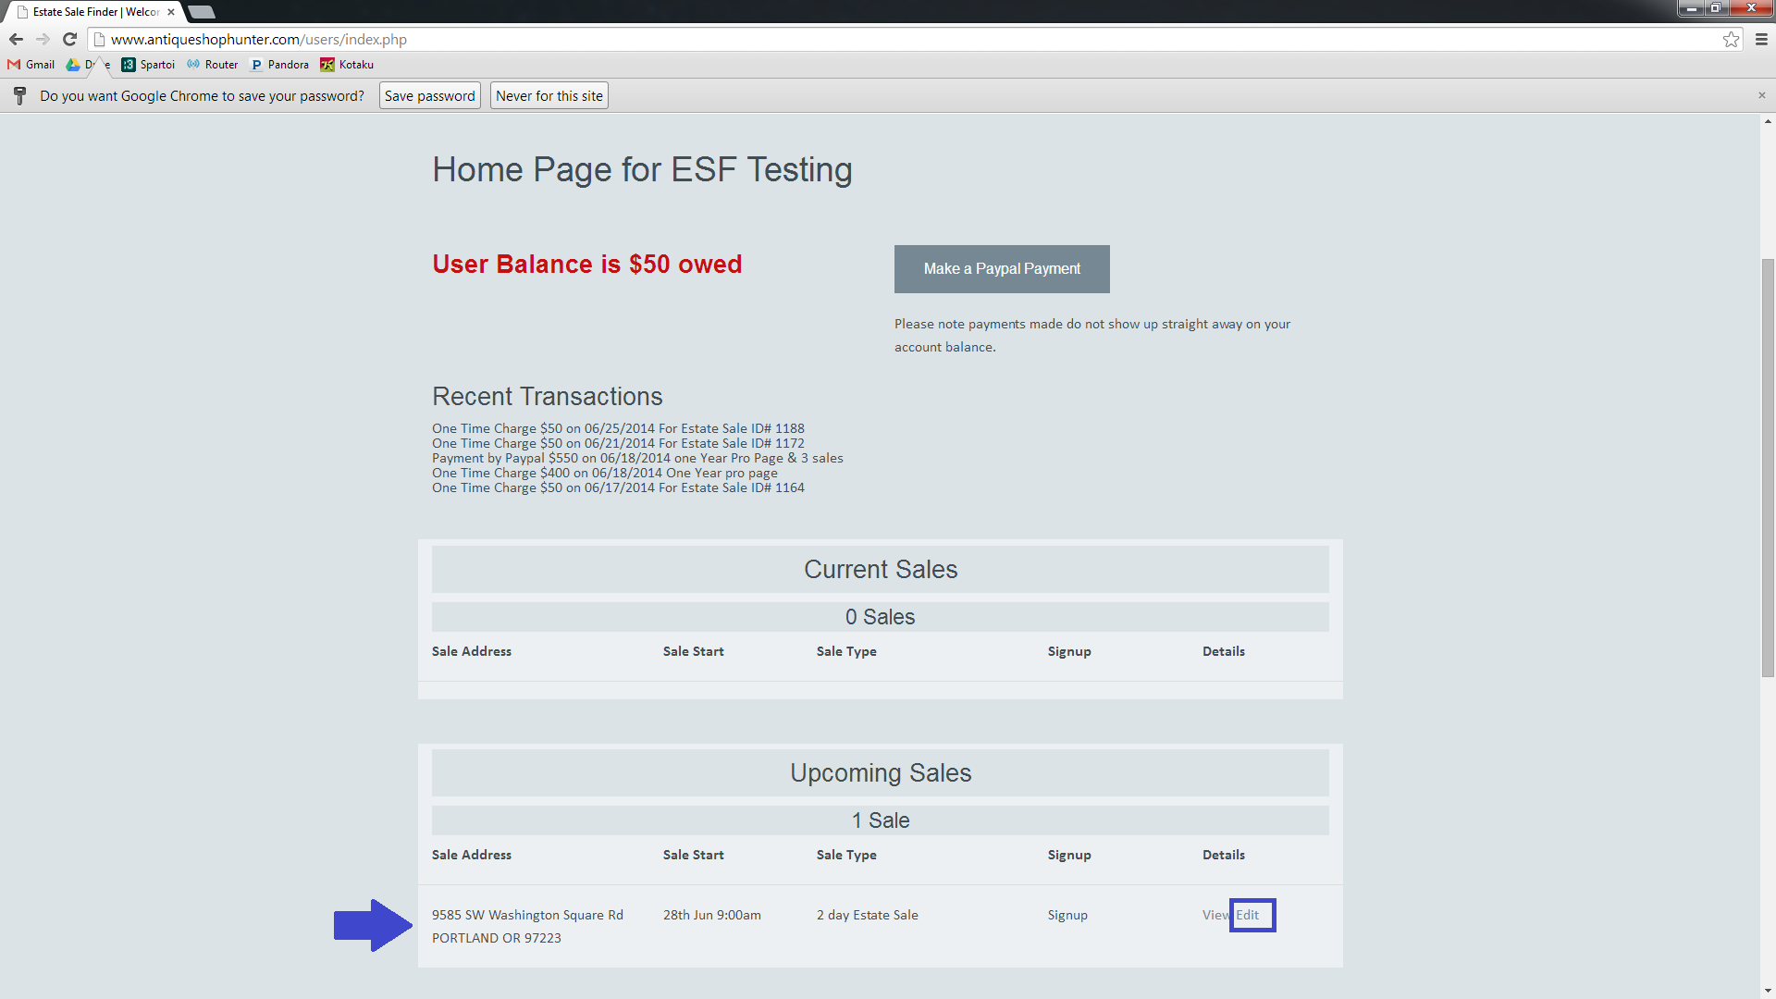

You are now able to edit the details of your sale.
If you only need to add or edit photos, you can click the ‘Add or Edit Photos’ button at the top of the page, and you will be redirected to the photo uploader. You will also have the option to add or edit photos after updating the sale text. If you want to see what your sale looks like on the website, you can use the ‘View Sale’ button. This will display sale information from BEFORE you began editing- In order to see the updated text, you’ll need to save it using the ‘Update Sale’ button at the bottom of the Sale Details page.
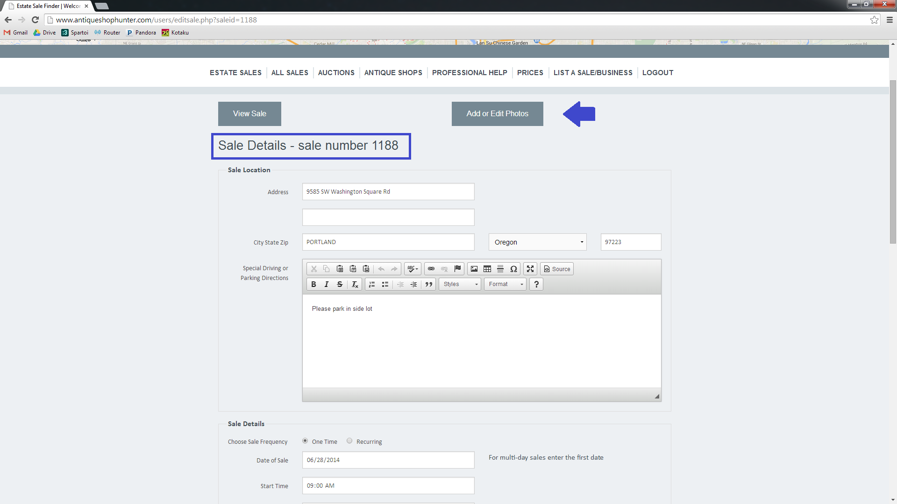
In edit mode, you have the ability to alter any sale details including dates, hours, sale type, special directions, text, signup details, and photos. You may also edit the time at which the address is posted.
The text box has a set of tools that allow you to customize the appearance of your posting. These features include font editing (bold, italic, strikethrough), bulleting & numbering options.
If you need to view a larger area of the free text boxes, simply click and drag the small arrow in the lower right corner of the free text box. This is just for your convienence; The entire text will display on your sale page regardless of the size of the text box on this form.
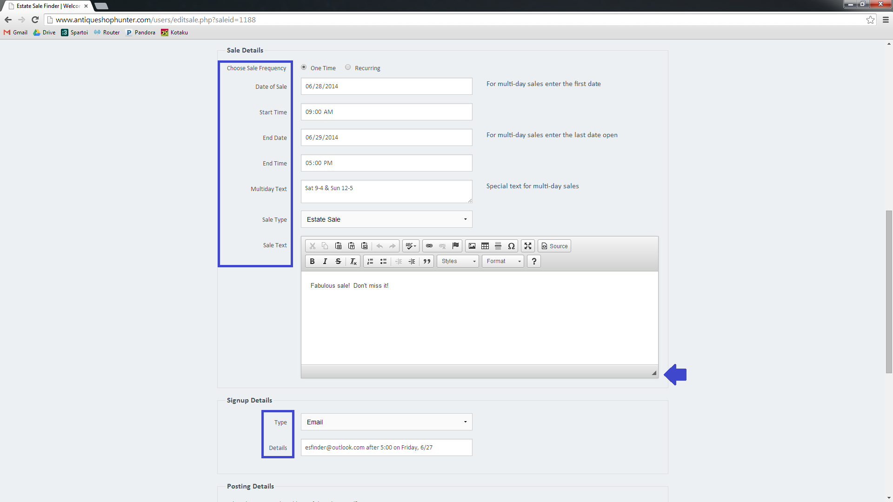
When you’re done editing your sale details, scroll to the bottom of the page and click the ‘Update Sale’ button.
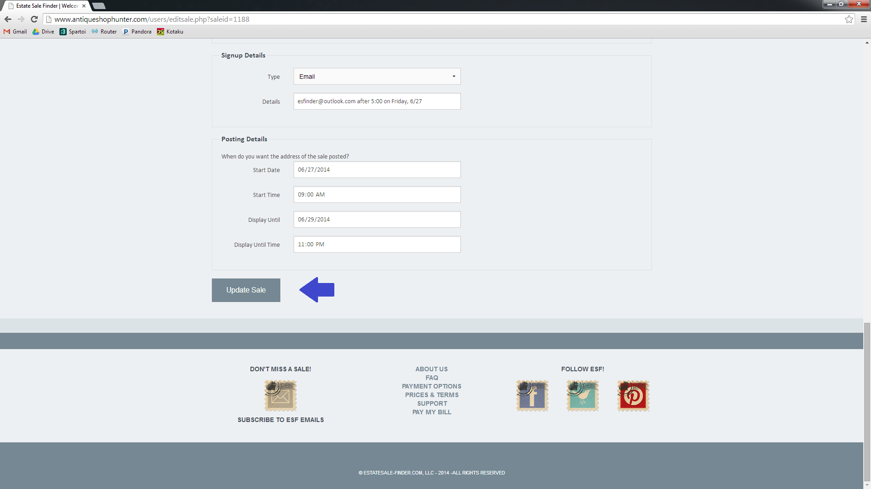

You will be redirected to the sale page. If you’re done, simply click on the ‘back to home’ hyperlink to return to your account homepage.
If you need to add or edit photos, you can do so at this time. To remove previously uploaded images, click the red ‘x’ in the upper left corner of the photo. To add more photos using the photo uploader, scroll to the bottom of the page.
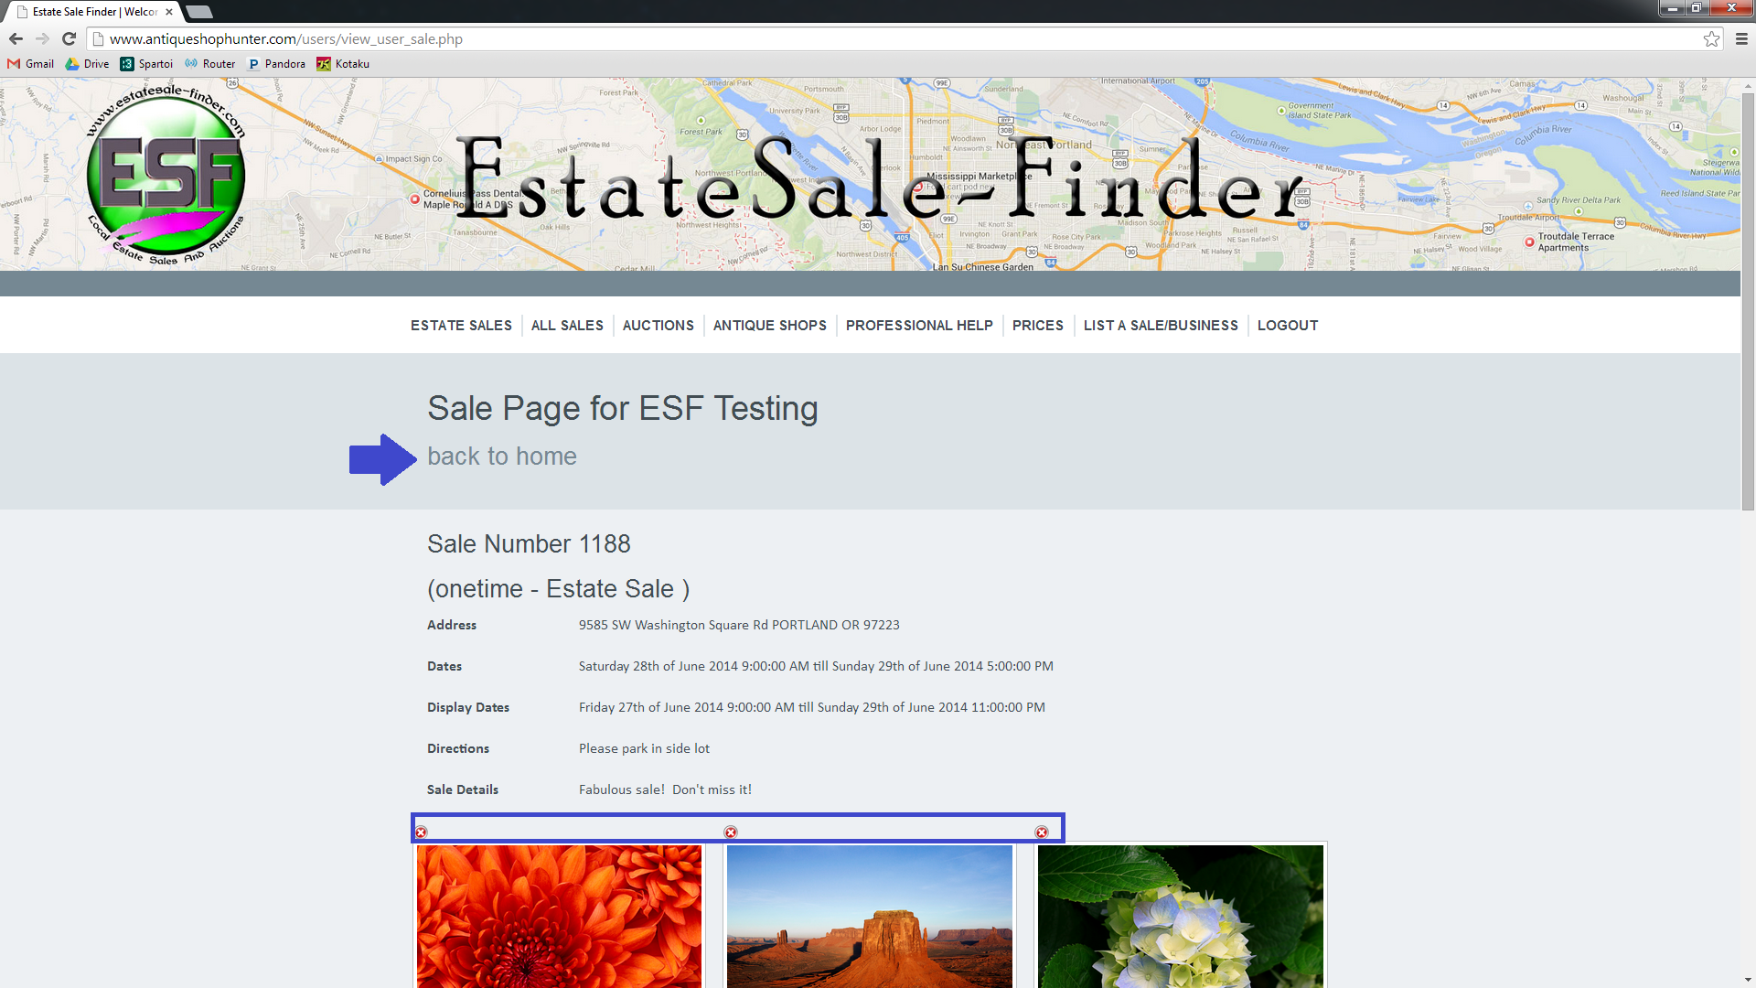

To begin adding more photos to an existing sale, click on the ‘Add More Photos’ button.
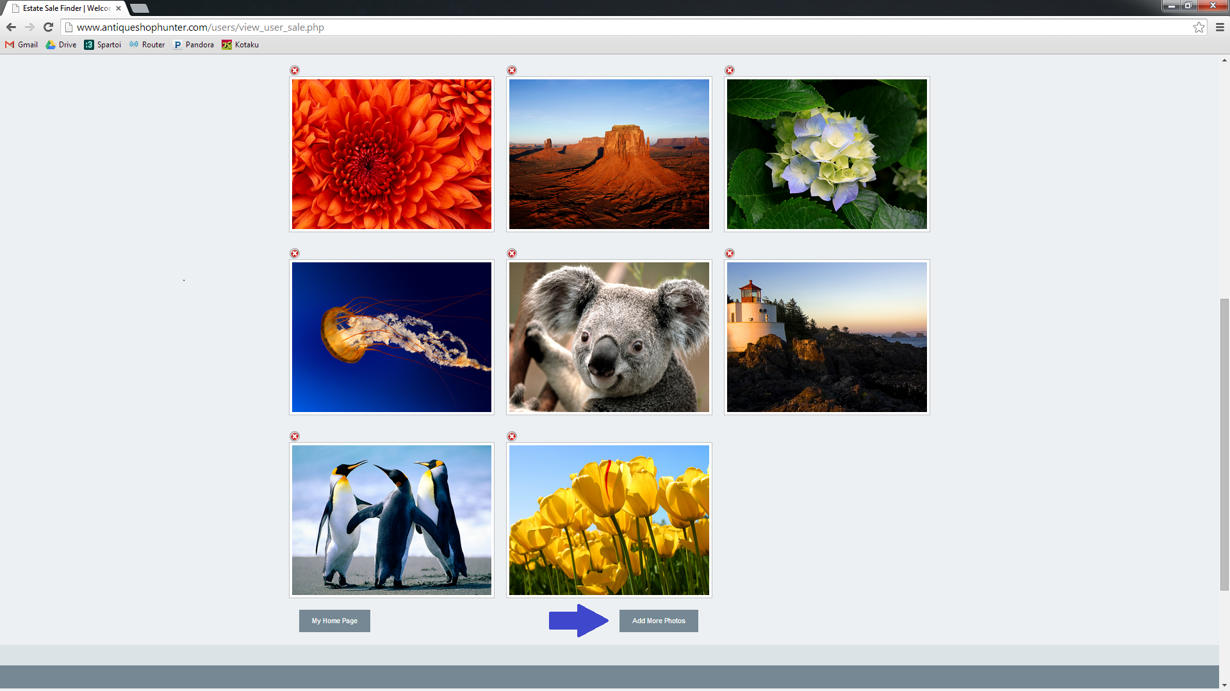

You’ll be redirected to the photo uploader. You can see that you have the option to view the existing photos, if you’d like. To select the files that you’d like to upload, click on the ‘Choose Files’ button.
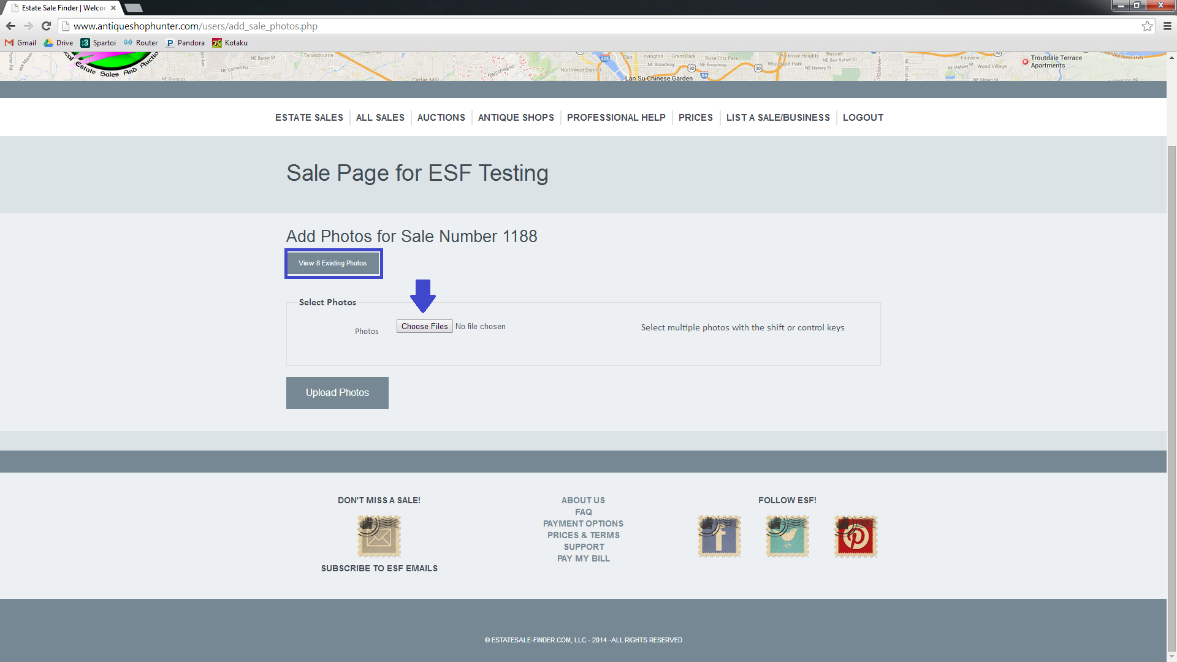

You’ll now have access to the files that are on your computer or attached memory device such as a phone, camera, or external hard drive.
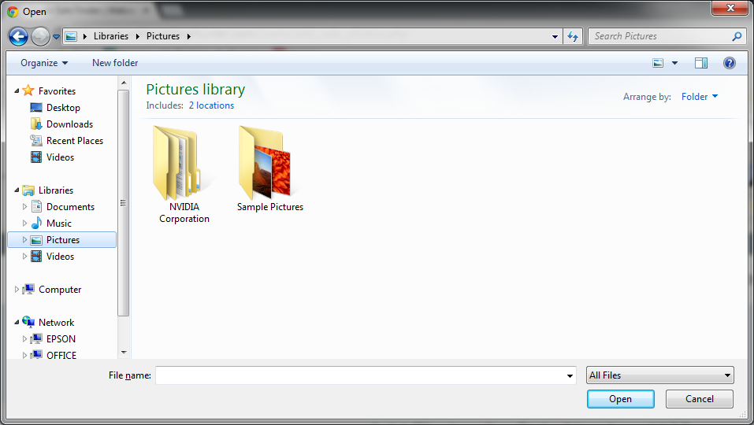

Navigate, as you normally would, to the location of your photo files. You can use the shift and ctrl keys to choose multiple files at one time.
To select a range of files, click on the first file, then hold the shift key and select the last file. This will capture all images in between. The photo uploader is most efficient when used for batches of 20 or fewer photos at a time.
If you want to pick-and-choose without selecting all photos in a given range, hold down the control key and click on each photo that you’d like to add.
You’ll see the list of selected files in the ‘File Name’ field. When you’ve selected all your photos, click ‘open.’
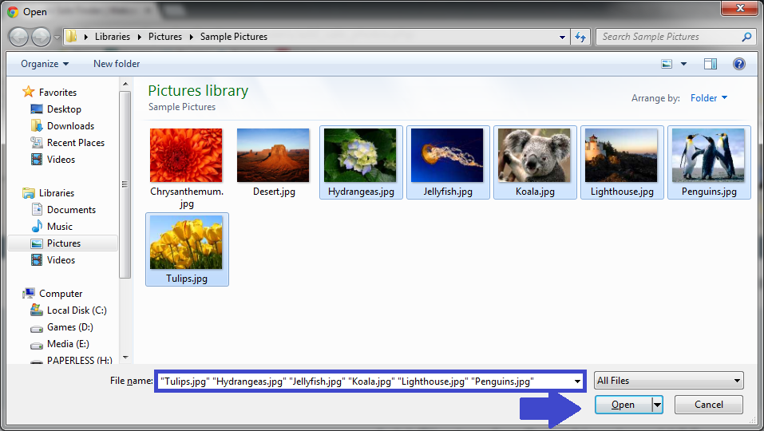

You can see that you’re back on the photo upload page. The photo uploader has detected that 6 more photos were selected to add to this sale.
Click ‘Upload Photos.” It will take a moment to upload the image files. The upload status is visible in the bottom left hand corner of your browser window.
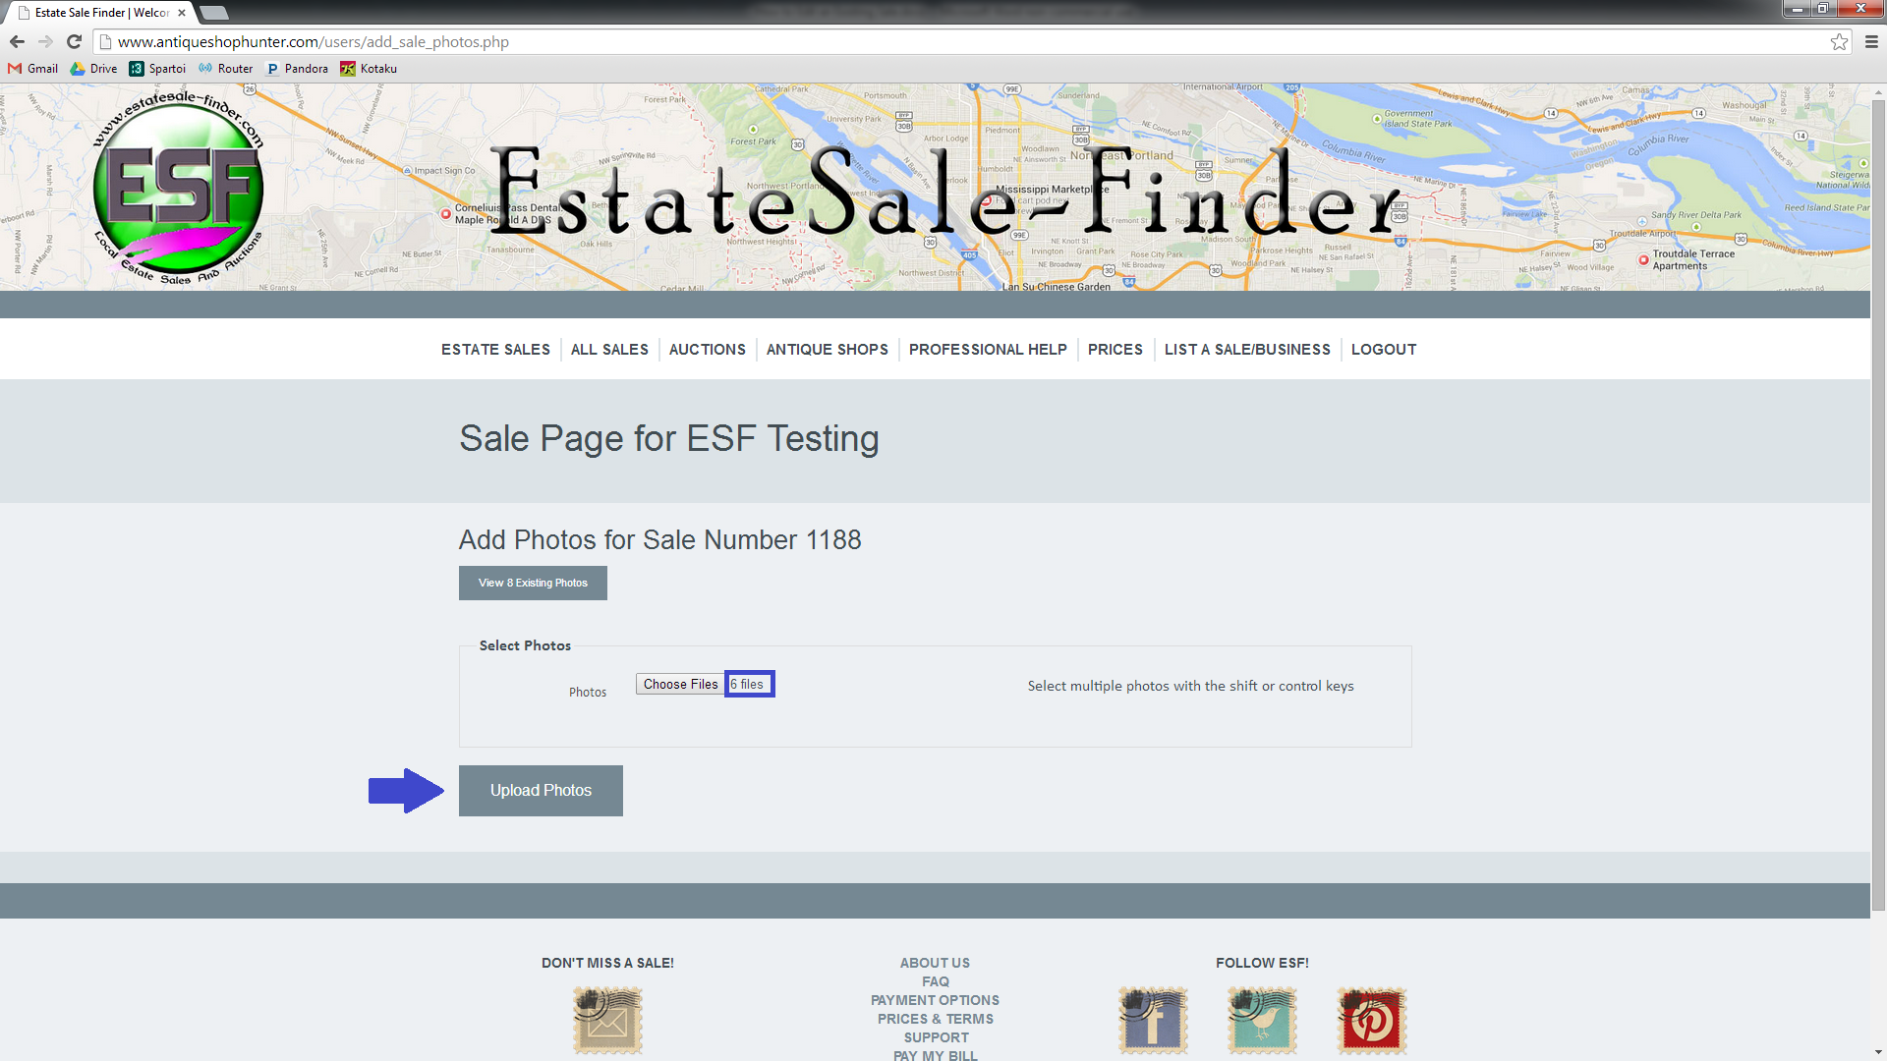

When the photos are finished uploading, you’ll be redirected to the sale page.
If you have more photos to add, click on ‘Add More Photos’ and repeat. If you are done, click on ‘My Homepage.’ You’re done!
